THE 2ND SUFUCA WORK SEMINAR IN TARTU, ESTONIA 12.3. – 13.3.2009
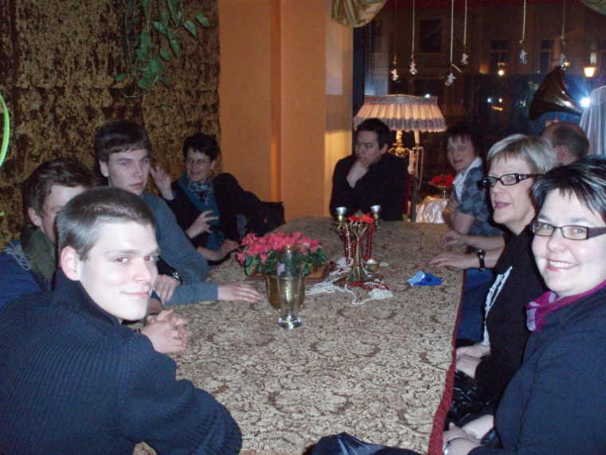
After travelling everyone is hungry, but still smiling when waiting for supper.
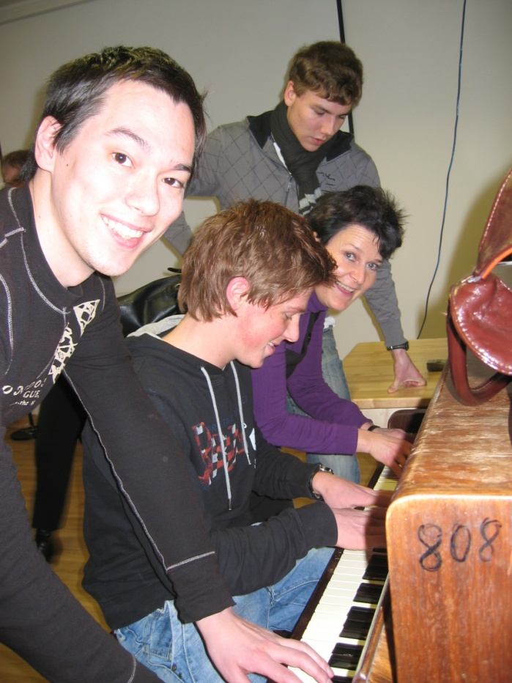
Music is good for your soul and the functional capacity.

