THE 3RD SUFUCA WORK SEMINAR IN KLEVE, GERMANY 24.9. – 25.9.2009
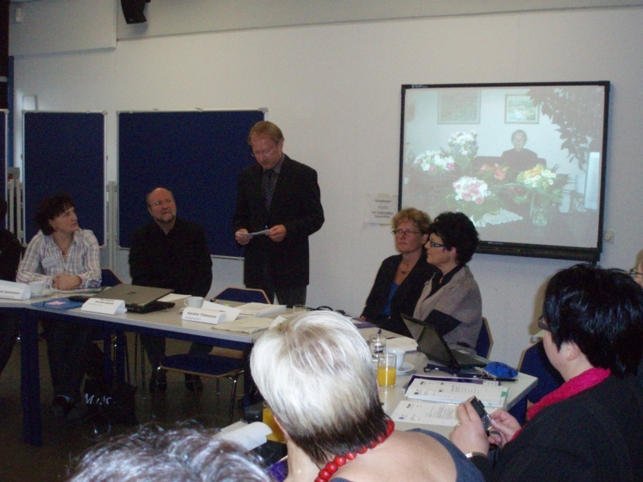
Mr. Hans Reder, the headmaster of Berufskolleg Kleve opened the work seminar days. After that enthusiastic project work together will begin.
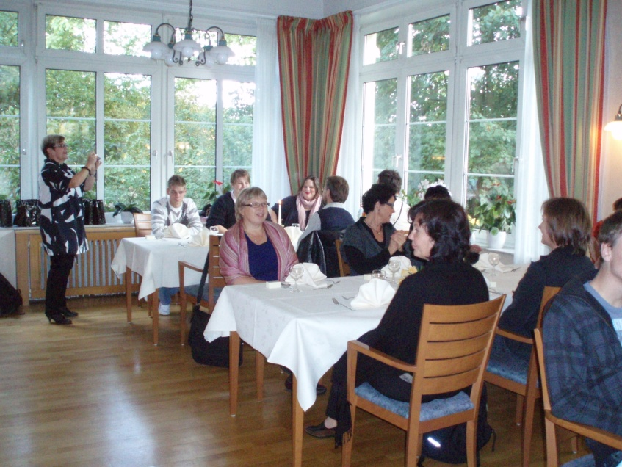
Visit to the beautiful residential home, Burg Ranzow. The project evaluator, Liisa, taking pictures.

