THE 4th SUFUCA WORK SEMINAR IN TARTU, ESTONIA 28.1. - 29.1.2010
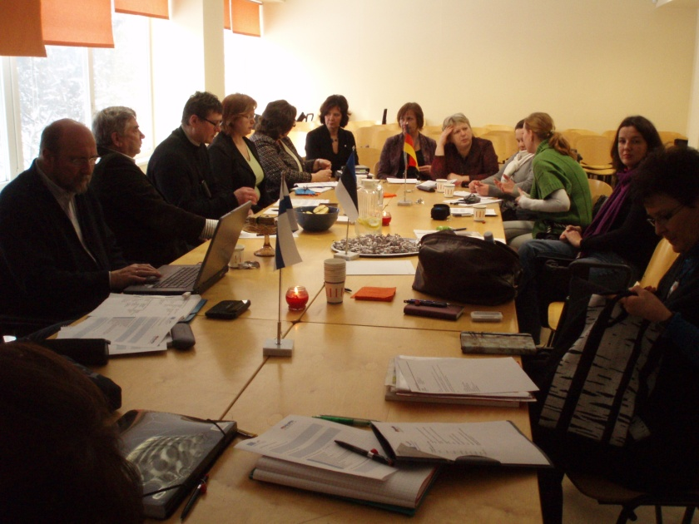
The project work is proceeding. Many good ideas and wise thoughts are shared.
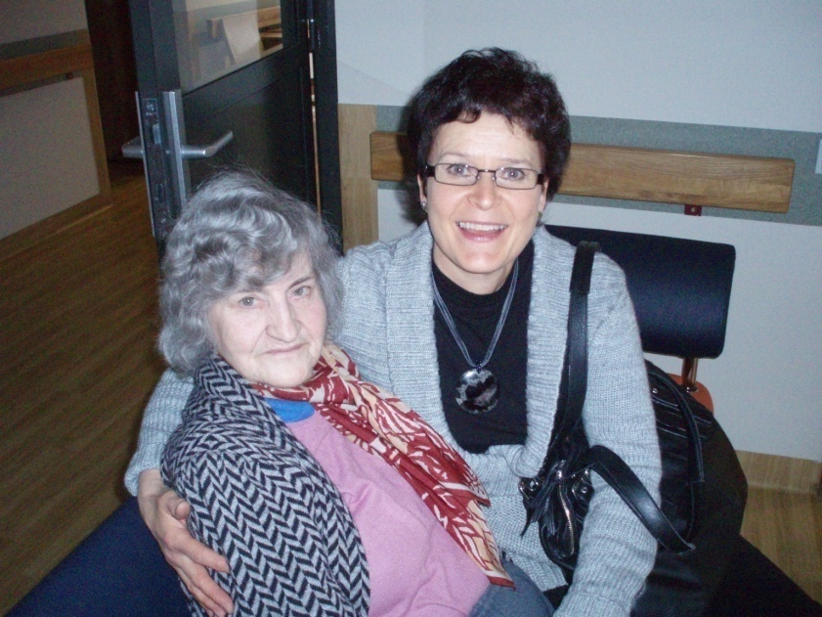
The project manager, Leena , has dear friends in Tartu Hooldekodu

